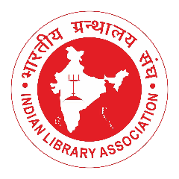
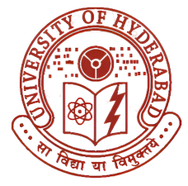
72nd Indian Library Association (ILA)
International conference on
Future Libraries: Advancing Research & Excellence (FLARE) 2027

Author Guidelines
Authors are requested to follow the submission and manuscript preparation guidelines prescribed for the conference. Adherence to these guidelines will facilitate a smooth review and publication process and ensure uniformity in the presentation of papers.
1. Originality and Scope
- Submitted papers must be original, unpublished, and not under consideration elsewhere.
- Articles should relate to the conference themes and sub-themes in the broad domain of Library and Information Science.
- Authors are responsible for the accuracy, originality, and ethical integrity of their work.

Formatting Requirements | Structure of the Paper
Manuscripts should be prepared in MS Word format (.doc/.docx).  Font: Times New Roman  Font Size: 12 pt  Line Spacing: 1.5  Margin: 1 inch on all sides  Alignment: Justified  Citation and Referencing Style : APA 7th Edition  Full papers should be within 3,500 words, including references, tables, and appendices.  Tables, Figures, and Illustrations  - Tables and figures must be numbered consecutively and cited within the text.  - Provide clear titles and sources wherever necessary.  - Images and graphics should be high-resolution and suitable for publication. | - Title of the Paper  - Author Details  - Name(s)  - Affiliation(s)  - Email address of the corresponding author  - Abstract (250–300 words)  - Keywords (3–6 keywords)  - Introduction  - Objectives of the Study  - Literature Review  - Methodology  - Analysis and Discussion  - Findings/Results  - Conclusion  - References  Authors may modify section headings depending on the nature of the study.

Ethical Considerations
- Plagiarism in any form is strictly prohibited.
- The similarity index should preferably be below the 10% limit.

Submission Process
- Authors should submit the manuscript through the conference submission portal/email before the deadline.
- Each submission will undergo peer review by the editorial and review committee.

